International School

Database Design and Data Mapping Document
Course: System Integration Practices
Project Title: Integrated HR & Payroll Dashboard System for Company X
Case Study 2: Models Integration
Version: 1.0
Date: 5/5/2026
Group: 5
Semester: 2 – Academic Year 2025–2026
Instructor: MSc. Nguyen Dang Quang Huy
Team Members:
Name | Student ID
Manh, Nguyen Van Duy | 29211100024
Loc, Tran Viet | 29211352994
Tin, Huynh Tran | 29211358847
Loi, Tran Van | 29211159367
Viet, Dang Dai | 29211155820

Approved by
MSc Huy, Nguyen Dang Quang
Group Project - Instructor:

Name Signature Date

Da Nang 05/2025
Project Acronym | HRD
Project Title | Company X – Integrated HR & Payroll Management Dashboard
Start Date | 16 March 2026 | End Date | 16 May 2026
Lead Institution | International School, Duy Tan University
Role | Name | Email |  | Phone
Project Mentor | Nguyen Dang Quang Huy | huyndq@duytan.edu.vn |  | 0935525354
 | Nguyen Van Duy Manh | duymanhdev@gmail.com |  | 0779534325
 | Tran Viet Loc | tranvietloc288@gmail.com |  | 0365957050
 | Huynh Tran Tin | trantin202ad@gmail.com |  | 0899565751
 | Tran Van Loi | tvl19012005@gmail.com |  | 0898238541
 | Dang Dai Viet | vdang9721@gmail.com |  | 0384165721

DOCUMENT INFORMATION
Document Title | Database Design - Data Maping - Template Document
Reporting Period | 5 - May - 2026
Author(s) | Dang Dai Viet  Nguyen Van Duy Manh
Role | Developer
Date | 5/5/2026 | File name | 6. Database Design - Data Maping-Template.docx

DOCUMENT APPROVALS
Document Approvals: The following signatures are required for approval of this document.
Mentor | Huy, Nguyen Dang Quang | Signature:
 |  | Date:
 |  | Date:
Team member(s) | Manh, Nguyen Van Duy | Signature:
 |  | Date:
 | Loc, Tran Viet | Signature:
 |  | Date:
 | Tin, Huynh Tran | Signature:
 |  | Date:
 | Loi, Tran Van | Signature:
 |  | Date:
 | Viet, Dang Dai | Signature:
 |  | Date:

TABLE OF CONTENTS
1. Introduction 6
1.1 Purpose 6
1.2 Scope 6
1.3 Definitions, Acronyms, and Abbreviations 6
1.4 References 7
2. System Overview 7
3. Database Description 8
3.1 HUMAN Database Schema 8
3.2 PAYROLL Database Schema 9
4. Data Mapping Specification 12
4.1 Employee Management Function 12
4.2 Department Management Function 12
4.3 Position Management Function 13
5. Integration Logic Explanation 13
6. Entity Relationship Diagram (ERD) 14
7. Summary and Future Work 15

1. Introduction

1.1 Purpose
- The primary purpose of this Database Design and Data Mapping Document is to detail the database structures of the two distinct enterprise systems used by Company X: the HUMAN system (managing human resources) and the PAYROLL system (managing financial and salary data). This document defines the exact table schemas, data types, and the logical data mapping rules required to synchronize information between these heterogeneous databases. This comprehensive mapping serves as the foundational blueprint for developing the integration API layer in subsequent phases of the project.

1.2 Scope
- This document focuses exclusively on the data layer of the integration project. It details the database schemas for both the HUMAN (SQL Server) and PAYROLL (MySQL) systems, the entity-relationship diagrams (ERDs), and the specific field-to-field mapping logic required for data synchronization.
- The scope of this document does not include the actual API source code implementation, network architecture, role-based access control (RBAC) mechanisms, or frontend dashboard design.

1.3 Definitions, Acronyms, and Abbreviations
Acronym/Term | Definition
HUMAN | Human Resource Management Database (SQL Server)
PAYROLL | Payroll Management Database (MySQL)
API | Application Programming Interface. The intermediary layer facilitating data exchange.
PK | Primary Key. A unique identifier for a record in a database table.
FK | Foreign Key. A field in one table that uniquely identifies a row of another table.
UK / UQ | Unique Key. A database constraint that ensures all values in a column or a set of columns are strictly distinct from one another.
ERD | Entity Relationship Diagram. A visual representation of database structures and relationships.
CRUD | Create, Read, Update, Delete. The four basic operations of persistent storage.

1.4 References
- Case Study 1 – Problem Statements
- Software Requirement Specification (SRS) Document
- IEEE Std 1016-2009 – Standard for Software Design Descriptions
- CMU-CS445 Course Material, Duy Tan University (2025)

2. System Overview
- Company X currently operates two independent systems that lack direct communication. The HUMAN system, built on SQL Server, acts as the master repository for all organizational data, including employee profiles, department structures, and job positions. The PAYROLL system, built on MySQL, relies on this HR data to process attendance, calculate monthly salaries, and manage deductions. The integration project aims to build an automated bridge between these systems, ensuring that any changes in the HR master database are accurately and securely synchronized to the financial database without manual data entry.
System | Database Type | Main Tables | Role in Integration
HUMAN | SQL Server | Employees, Departments, Positions | Source of employee data
PAYROLL | MySQL | employees_payroll, salaries, attendance | Destination for payroll records

3. Database Description

HUMAN Database Schema
- Table: Employees: This table stores the core profile information for all staff members within the company. It serves as the primary entity in the HR system.
Field Name | Data Type | Key | Description
EmployeeID | INT | PK | Unique employee identifier
FullName | NVARCHAR(100) |  | Employee's full legal name
DateOfBirth | DATE |  | Date of birth
Gender | NVARCHAR(10) |  | Gender
PhoneNumber | NVARCHAR(15) |  | Contact phone number.
Email | NVARCHAR(100) | UQ | Email address (Must be unique).
HireDate | DATE |  | Start date of employment
DepartmentID | INT | FK | Reference to the Department table
PositionID | INT | FK | Reference to the Position table
Status | NVARCHAR(50) |  | Current employment status (e.g., Active)
CreatedAt | DATETIME |  | Timestamp of record creation
UpdatedAt | DATETIME |  | Timestamp of last record update

- Table: Departments: This table maintains the organizational structure, defining the various departments within Company X.
Field Name | Data Type | Key | Description
DepartmentID | INT | PK | Unique department identifier
DepartmentName | NVARCHAR(100) |  | Official name of the department
CreatedAt | DATETIME |  | Timestamp of record creation
UpdatedAt | DATETIME |  | Timestamp of last record update

- Table: Positions: This table catalogs the different job titles and roles available within the company.
Field Name | Data Type | Key | Description
PositionID | INT | PK | Unique position identifier
PositionName | NVARCHAR(100) |  | Official job title
CreatedAt | DATETIME |  | Timestamp of record creation
UpdatedAt | DATETIME |  | Timestamp of last record update

- Table: Dividend: This table records profit-sharing and dividend payouts for employees.
Field Name | Data Type | Key | Description
DividendID | INT | PK | Unique dividend transaction identifier
EmployeeID | INT | FK | Reference to the employee receiving the dividend
DividendAmount | DECIMAL(12,2) |  | The amount of the dividend paid
DividendDate | DATE |  | The date the dividend was issued
CreatedAt | DATETIME |  | Timestamp of record creation

3.2 PAYROLL Database Schema
- Table: employees_payroll: This table is a synchronized copy of the HR employee data, maintained within the MySQL database to ensure local reference integrity for financial operations without continuously querying the SQL Server.
Field Name | Data Type | Key | Description
EmployeeID | INT | PK | Synchronized unique employee ID
FullName | VARCHAR(100) |  | Synchronized employee name
DepartmentID | INT |  | Synchronized department ID
PositionID | INT |  | Synchronized position ID
Status | VARCHAR(50) |  | Synchronized employment status.
SyncedAt | DATETIME |  | Timestamp of the API synchronization

- Table: departments_payroll: A synchronized copy of departments from the HR system.
Field Name | Data Type | Key | Description
DepartmentID | INT | PK | Department ID (Synchronized from HR)
DepartmentName | VARCHAR(100) |  | Department name
SyncedAt | DATETIME |  | Timestamp of the API synchronization

- Table: positions_payroll: A synchronized copy of positions from the HR system.
Field Name | Data Type | Key | Description
PositionID | INT | PK | Position ID (Synchronized from HR)
PositionName | VARCHAR(100) |  | Position name
SyncedAt | DATETIME |  | Timestamp of the API synchronization

- Table: salaries: This table stores the monthly financial compensation details for each employee. It is strictly maintained within the payroll system.
Field Name | Data Type | Key | Description
SalaryID | INT | PK | Unique salary record identifier (Auto-increment
EmployeeID | INT | FK | Reference to employees_payroll
SalaryMonth | DATE |  | The specific month of the payroll record
BaseSalary | DECIMAL(12,2) |  | Standard monthly wage
Bonus | DECIMAL(12,2) |  | Performance or variable bonuses
Deductions | DECIMAL(12,2) |  | Taxes, insurance, or disciplinary deductions
NetSalary | DECIMAL(12,2) |  | Final calculated payout amount
CreatedAt | DATETIME |  | Timestamp of record creation

- Table: attendance: This table tracks the time and attendance records used to calculate components like bonuses or deductions.
Field Name | Data Type | Key | Description
AttendanceID | INT | PK | Unique attendance record identifier
EmployeeID | INT | FK | Reference to employees_payroll
WorkDays | INT |  | Total days present
AbsentDays | INT |  | Days absent without leave
LeaveDays | INT |  | Approved leave days taken
AttendanceMonth | DATE |  | The reporting month for this attendance
CreatedAt | DATETIME |  | Timestamp of record creation

4. Data Mapping Specification

4.1 Employee Management Function
- Employee Data Mapping
HUMAN Table | Field | PAYROLL Table | Field | Mapping Description
Employees | EmployeeID | employees_payroll | EmployeeID | Primary key mapping
Employees | FullName | employees_payroll | FullName | Direct value copy
Employees | DepartmentID | employees_payroll | DepartmentID | FK reference copied for reporting context
Employees | PositionID | employees_payroll | PositionID | FK reference copied for reporting context
Employees | Status | employees_payroll | Status | Direct value copy
API Sync Action |  | employees_payroll | SyncedAt | Auto-generated timestamp upon API execution

4.2 Department Management Function
- Department Data Mapping
HUMAN Table | Field | PAYROLL Table | Field | Mapping Description
Departments | DepartmentID | departments_payroll | DepartmentID | Primary key mapping
Departments | DepartmentName | departments_payroll | DepartmentName | Direct value copy
API Sync Action | DepartmentID | departments_payroll | SyncedAt | Auto-generated timestamp upon API execution.

4.3 Position Management Function
- Position Data Mapping
HUMAN Table | Field | PAYROLL Table | Field | Mapping Description
Positions | PositionID | positions_payroll | PositionID | Primary key mapping
Positions | PositionName | positions_payroll | PositionName | Direct value copy
API Sync Action | DepartmentID | positions_payroll | SyncedAt | Auto-generated timestamp upon API execution.

5. Integration Logic Explanation
The synchronization between the HUMAN (SQL Server) and PAYROLL (MySQL) databases is governed by an external API integration layer. The fundamental rule is that the HUMAN database acts as the single source of truth for all HR-related entities (Employees, Departments, Positions). Any Create, Update, or Delete (CRUD) operation targeting these entities must be initiated against the HUMAN database.
When an API endpoint receives a request, the integration logic initiates a distributed transaction. The data is first written to the SQL Server database. If successful, the API layer immediately pushes the corresponding mapped data (as defined in Section 4) to the MySQL database. To ensure data integrity, the system employs a two-phase commit-like rollback mechanism: if the write operation to the MySQL database fails (due to connection issues or constraint violations), the preceding successful write to the SQL Server is rolled back. This ensures that both databases remain in a consistent state and prevents orphaned records. Read operations for financial data interact directly and solely with the MySQL database.

6. Entity Relationship Diagram (ERD)
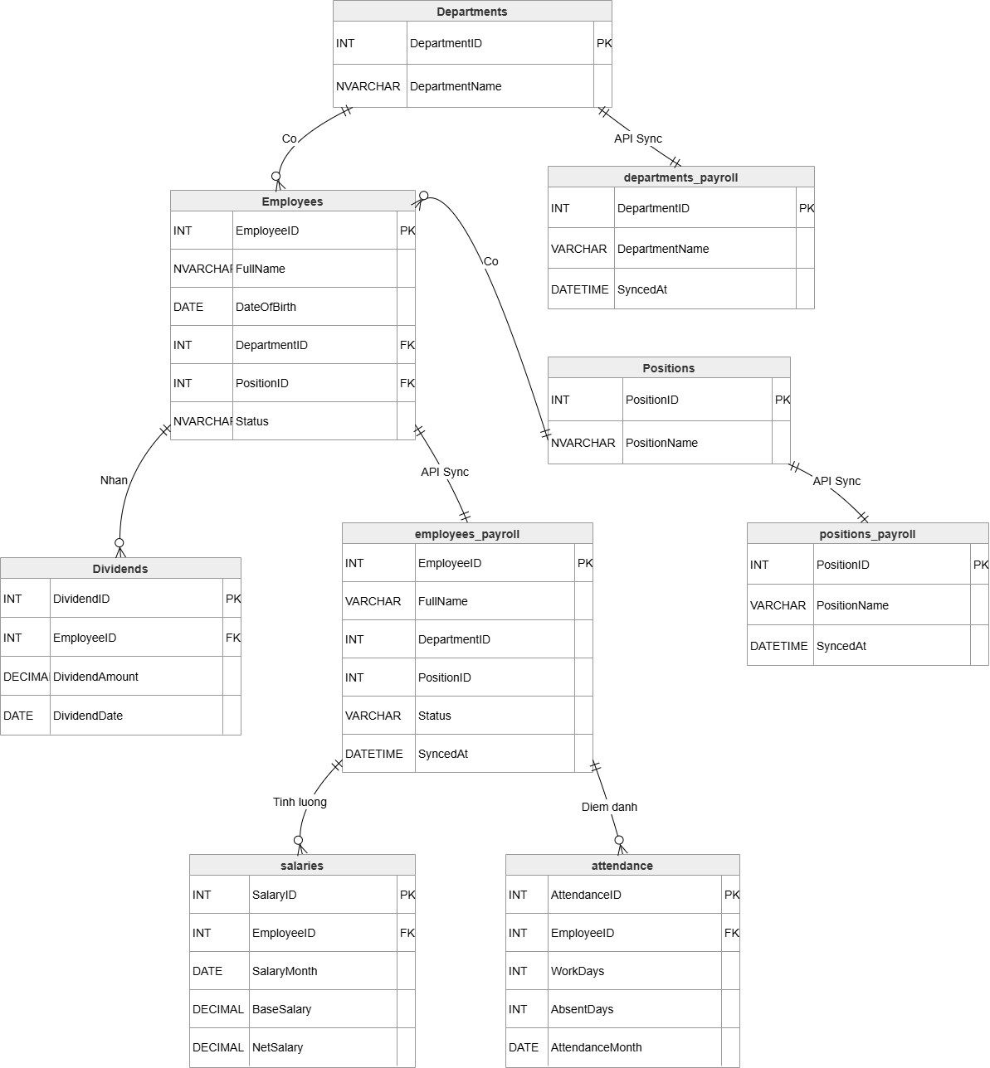

7. Summary and Future Work
- This Database Design and Data Mapping Document establishes the structural foundation required for integrating Company X's disjointed HR and Payroll systems. By explicitly defining table schemas and field-level mapping rules, this document ensures that data types align correctly across SQL Server and MySQL platforms. This mapping specification is critical, as it serves as the direct input for Case Study 3, where these rules will be codified into operational RESTful APIs, complete with transaction handling and synchronization logic. Future work will involve implementing these APIs, testing the synchronization workflows, and eventually building the front-end dashboard that consumes this integrated data layer.

